CAPTURING THE BENEFITS OF LEARNING
PILOT PROJECT OF THE COMMUNITY EDUCATION PROGRAMME
LIMERICK CITY ADULT EDUCATION SERVICE

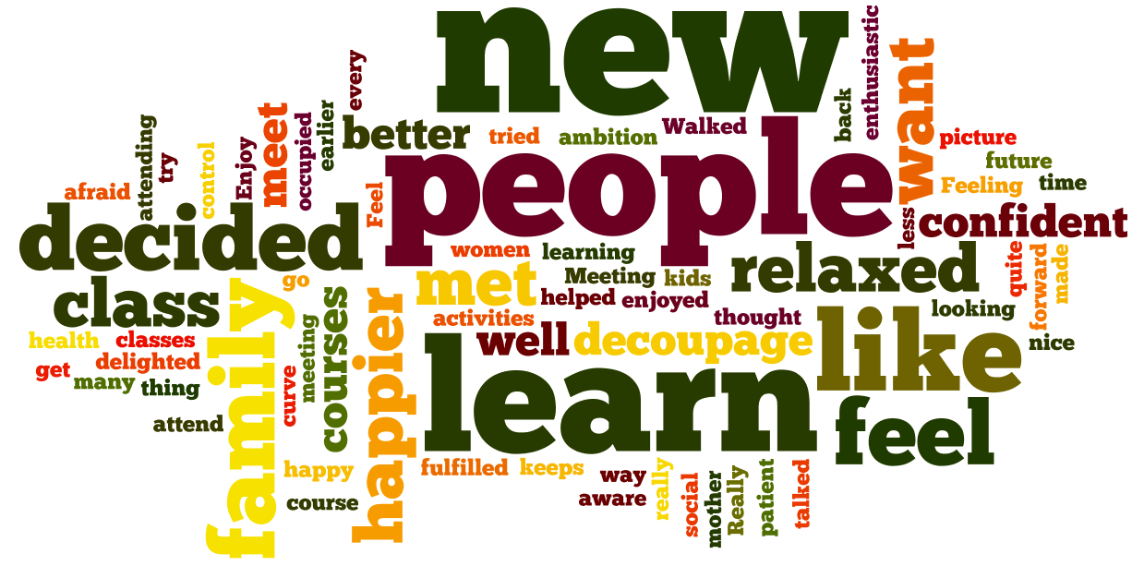

Foreword
There is a wealth of anecdotal feedback from learners about the positive impact of participation in community education. However, gathering such information in a systematic way with a large learner population and presenting it in an accessible and concise manner has been a challenge within community education.
This pilot initiative of Limerick City AES Community Education programme entitled ‘Capturing the Wider Benefits of Learning’ set out to devise simple tools and methodologies around two elements of non-formal learning:
- Learning outcomes which learners used to assess their skill level ‘before and ‘after’ participating in uncertified courses.
- Evidence about the wider benefits of learning specifically the impact of community education on four key areas of people’s lives namely, 1) personal development, 2) health and wellbeing, 3) family and community and 4) education and employment.
The tools/methodologies were devised by Tara Robinson, Curriculum Development Officer with LCAES in consultation with Community Education Tutors and programme staff. This booklet contains a sample of the collated feedback from the pilot project to capture the skills development and wider benefits of learning based on learners’ self-assessment. The feedback verified much of the anecdotal information about the wider benefits of learning.
The information in this booklet is from 11 sample courses and is presented in a standard format on each page as follows:
- The bar chart shows the ‘before and after’ ratings of learning outcomes set by groups of learners. The subject name and venue is given at the top of each bar chart.
- The ‘word cloud’ immediately below the bar chart shows all of the text which appeared on the self-assessment tool describing the impact of community education on four key areas of people’s lives namely, 1) personal development, 2) health and wellbeing, 3) family and community and 4) education and employment.
- The last ‘word cloud’ on each page gives greater prominence to those words that appear most frequently in the text.
The final section of the booklet contains Tutor guidelines for using the tool/methodology.

Mary Flannery
Community Education Facilitator
Limerick City Adult Education Service
November 2011

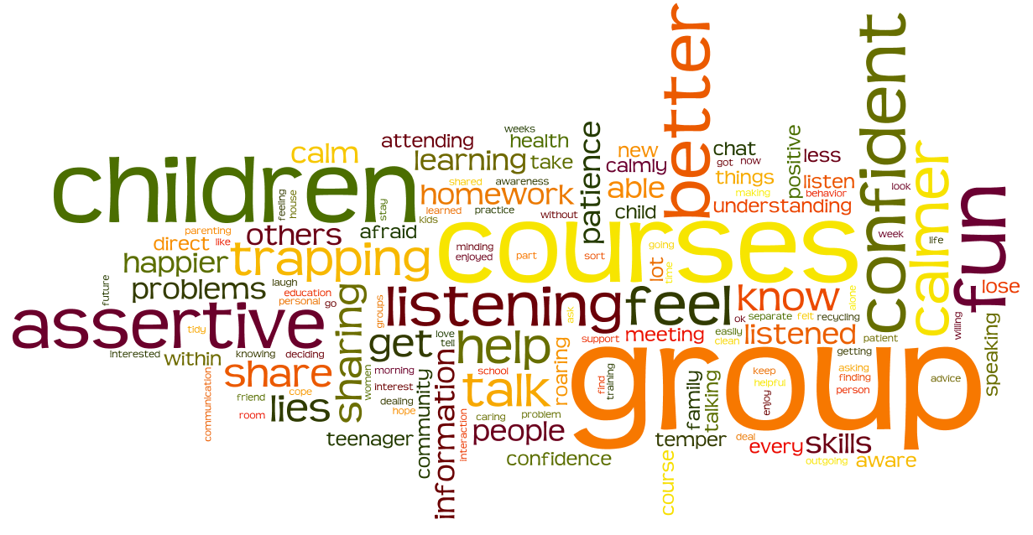

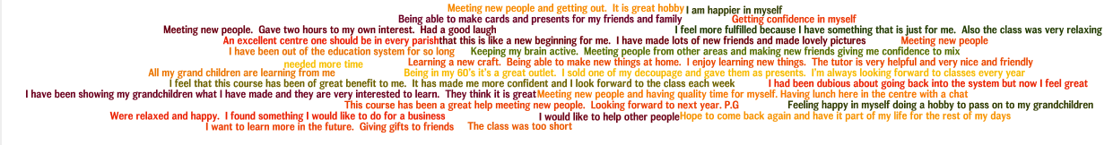
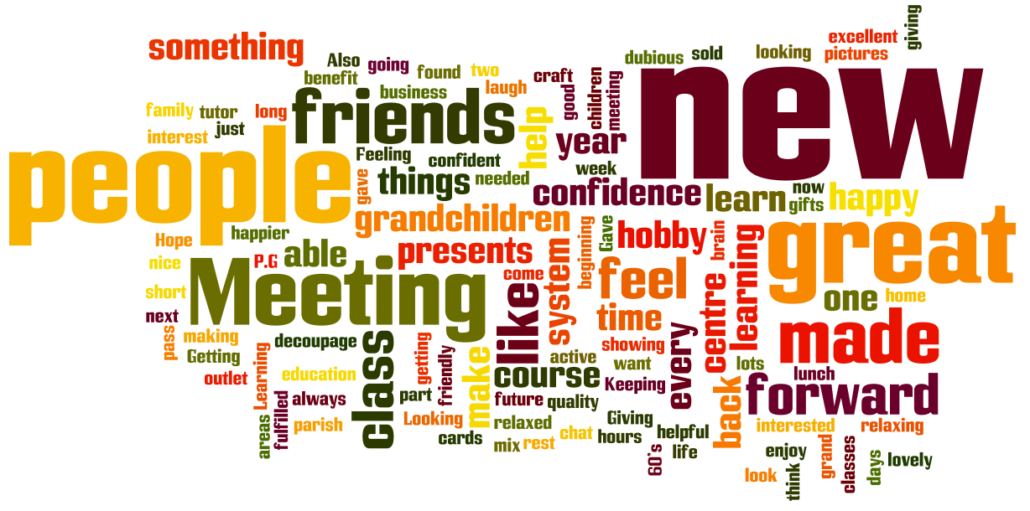

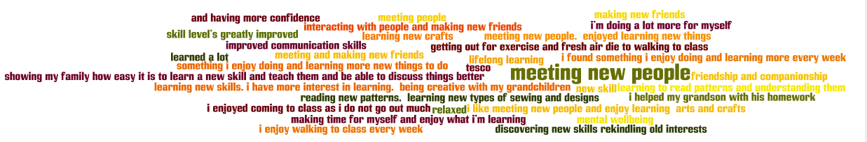
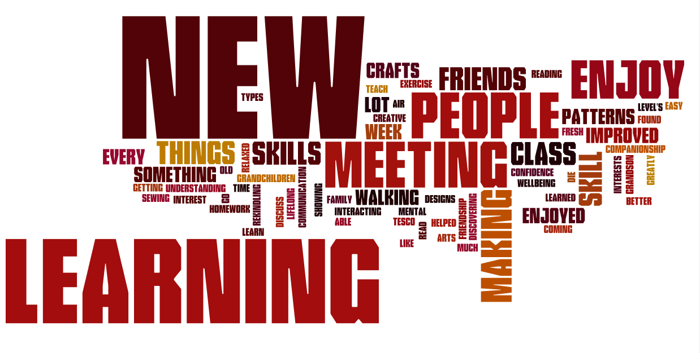

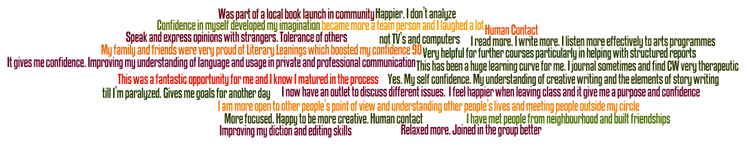
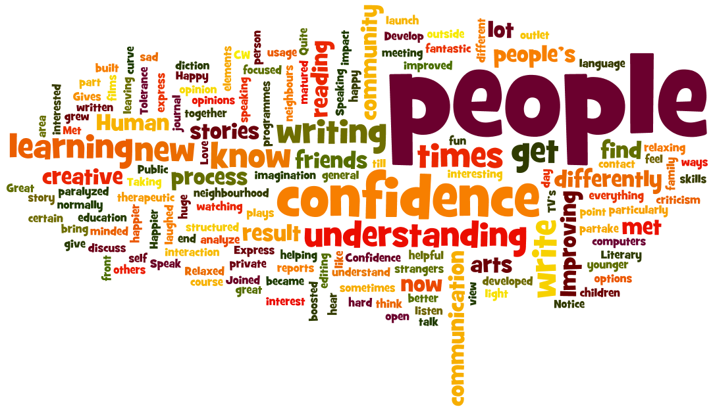

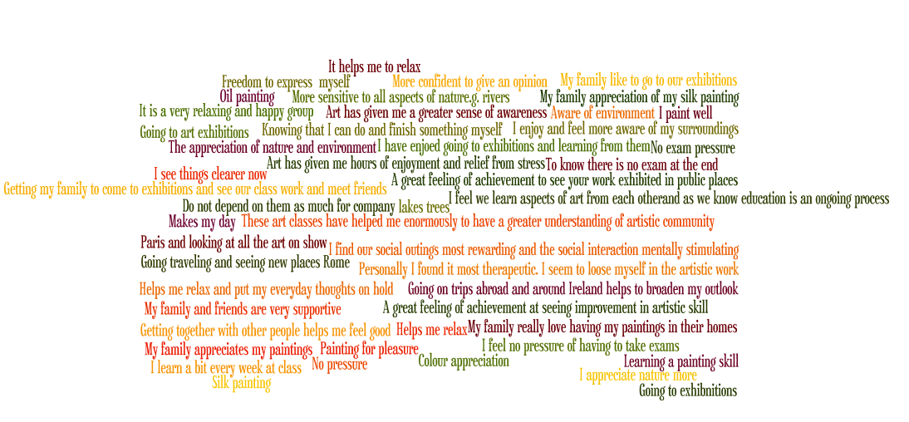
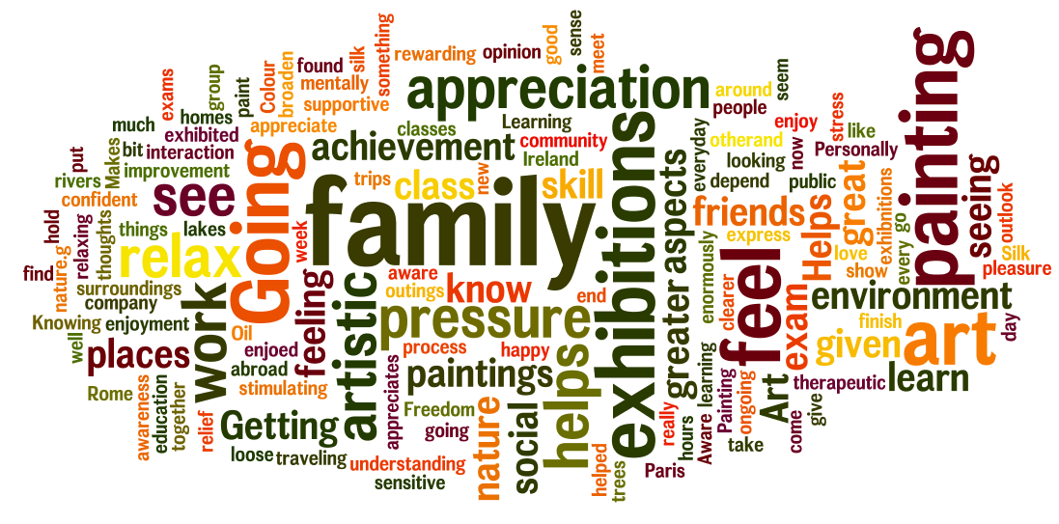

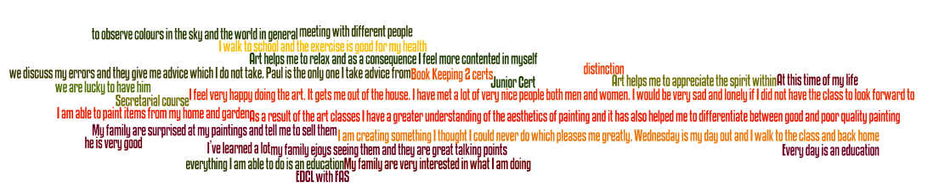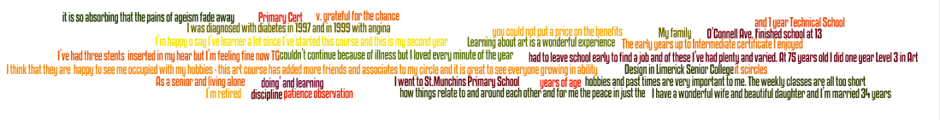
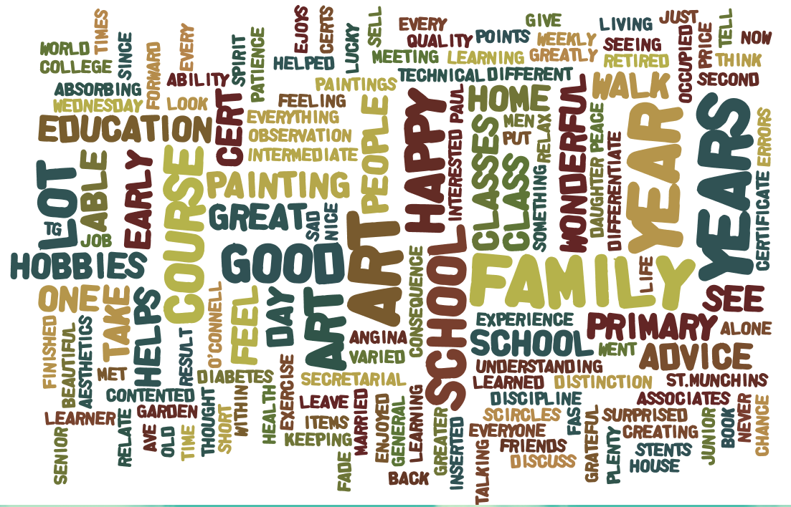

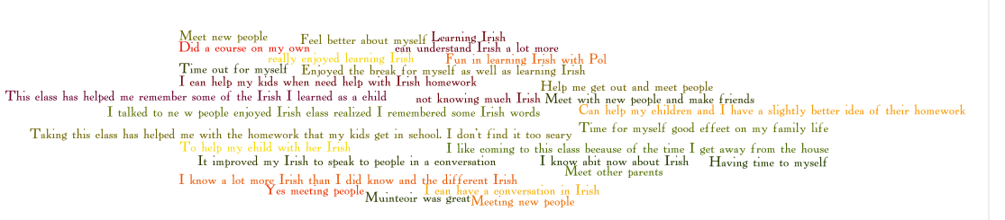
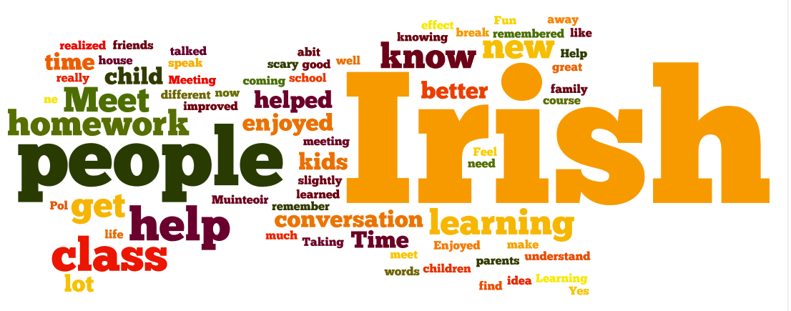

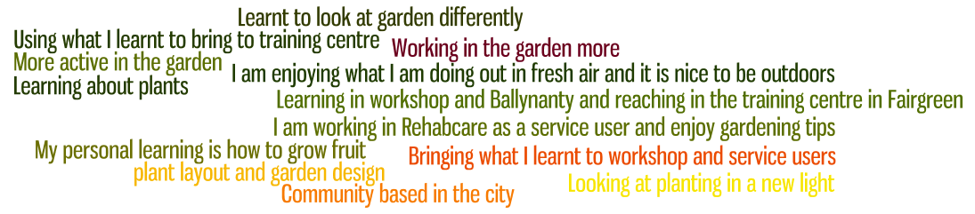
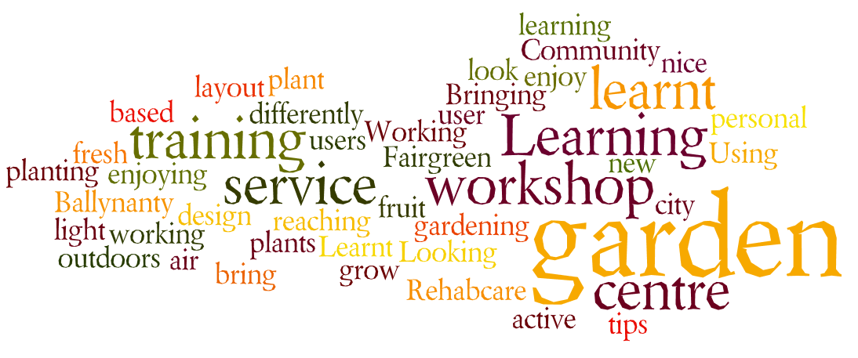

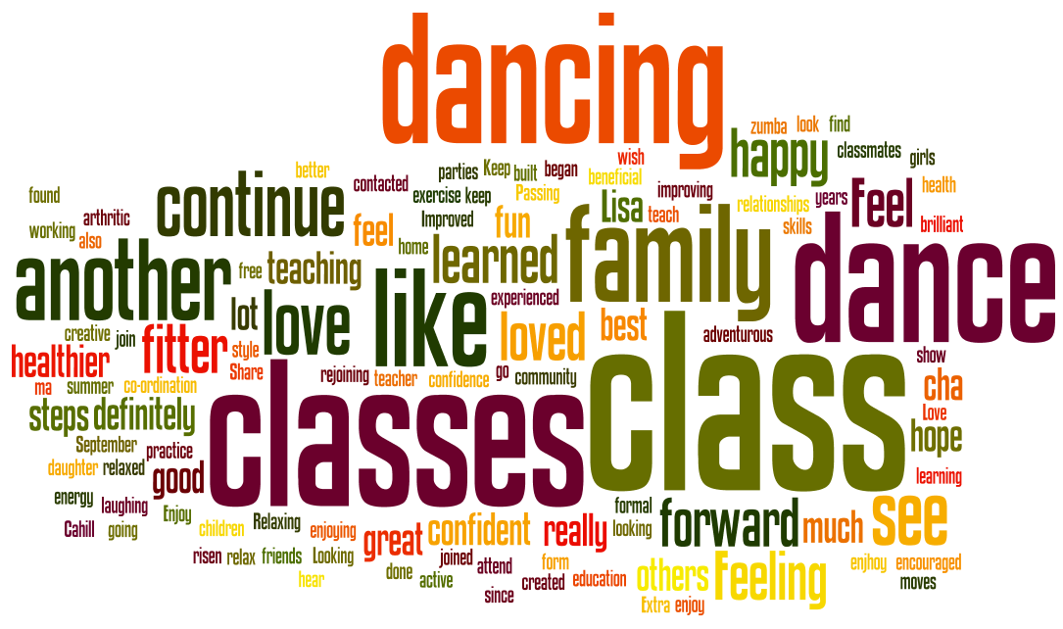

Tutor Guidelines for Capturing the Wider Benefits of Learning
Community Education
What Is It? A self assessment tool/methodology designed to rate learners’ progress in learning and to capture the benefits of learning.
Why Use This Tool/methodology?
- To find out what learners want from the course and set learning outcomes.
- To allow learners at the end of the course to reflect on their progress and identify benefits of learning.
- To record vital data about the impact of Community Education courses which will help Community Centres and LCAES Community Education programme with reporting and planning.

How to Use This Tool/Methodology?

Step One: Setting Group Learning Outcomes.
- In the first session discuss the tool/methodology.
- In pairs or on their own ask learners to answer an open ended question such as
  - By the end of this course I would like to...../By the end of this course I would like to be better at.....
- Record feedback from the group on a flipchart.
- After the session summarise feedback into 3 or 4 group learning outcomes. Include any important outcomes identified as part of your own planning process that might be missing.
- Phrase the outcomes so that they are I statements.
- Type or write your outcomes into Capturing the Benefits of Learning document along the light blue strip and give a completed copy to learners.

Step Two: Reflecting on the learning.
- In the last session learners will be guided through the completion of the Capturing the Benefits of Learning Assessment Tool/methodology.
- Discuss tool/methodology and its purpose. Let learners know that the information may be used for reporting purposes.
- Recap on the summarised learning outcomes, identified by learners at the start of the course.
- On Side One of the Tool/methodology ask learners to assign a number to each learning outcome by comparing where they were at the start of the course to where they are now. 1 being (not confident/knowing little )- up to 10 (very confident/ knowing a lot)
- Tutor should discuss how other benefits may have also arisen from learning, see the examples of Wider Benefits of Learning. On Side Two ask learners to write any impacts they experienced as a result of the learning in the each of the four areas. Be mindful that you may have to help with literacy.

Step Three:
- Collect the information and review for your own records.
- Send to the Community Education Facilitator at the end of your course along with your claim form.

Outcome 1:
Where was I before I started this course?  1 2 3 4 5 6 7 8 9 10 | Where am I now?  1 2 3 4 5 6 7 8 9 10
Outcome 2:
Where was I before I started this course?  1 2 3 4 5 6 7 8 9 10 | Where am I now?  1 2 3 4 5 6 7 8 9 10
Outcome 3:
Where was I before I started this course  1 2 3 4 5 6 7 8 9 10 | Where am I now  1 2 3 4 5 6 7 8 9 10
Outcome 4:
Where was I before I started this course  1 2 3 4 5 6 7 8 9 10 | Where am I now  1 2 3 4 5 6 7 8 9 10
Outcome 5:
Where was I before I started this course  1 2 3 4 5 6 7 8 9 10 | Where am I now  1 2 3 4 5 6 7 8 9 10
Side One: Compare where you are now with where you were at the start of your course for each outcome. Put a circle around the number.

Side Two: Has taking part in this class had any impact on you in any of the following areas? Fill your answer in the bubble.
My Personal Learning

My Health and Wellbeing

My Family or My Community

My Future Plans for Education or Employment

Examples of Wider Benefits of Learning
My Family or my Community
- I help the kids with their homework
- I got on better with my family
- I have more contact with my family
- I am more patient with my kids
- I went to a parent teacher meeting
- I questioned a local politician
- I volunteered in my local community centre
- I voted in the last election

My Future Plans for Education or Employment
- I feel less afraid of attending a course now
- I went and got some advice on looking for a job
- I found something I would love to do for a living
- I sold one of my paintings
- I made plans to go back to a course full time
- I decided I want to learn more

My Health and Wellbeing
- I started walking every day
- I went to the doctor for the first time in ages
- I talked to someone about giving up cigarettes
- I am more aware of my health
- I take more time out for me when I get stressed
- I feel more positive and hopeful about life
- I am happier in myself
- I know where to go for help

My Personal Learning
- I talked to new people
- I feel more confident
- I feel more in control of my life
- I tried out new activities
- I stood up for myself
- I am more understanding of myself
- I visited new places

